How To

Make a Field required
On an existing form

- Open Application Setup, choose in Advanced Setup: Forms
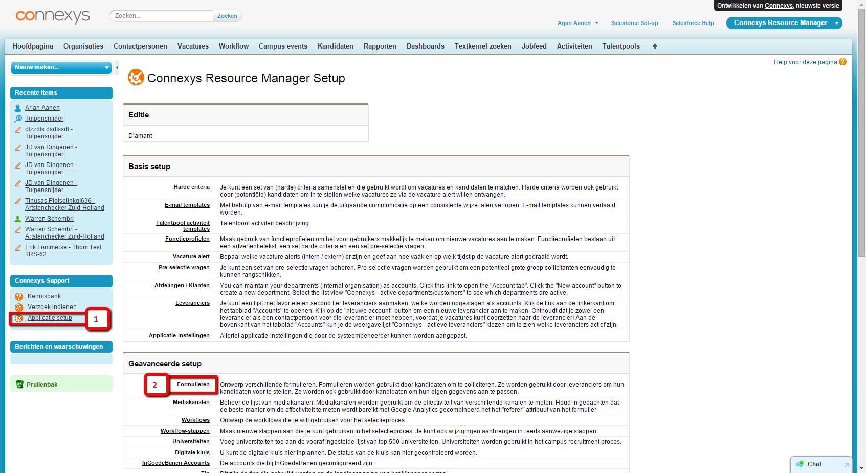

- Choose the form.
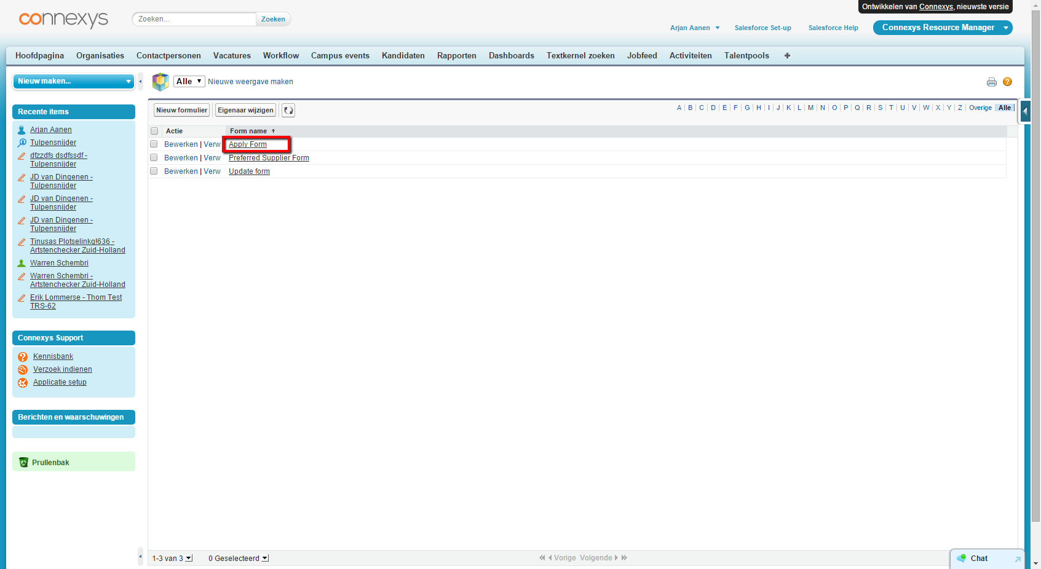

- Navigate to the layout
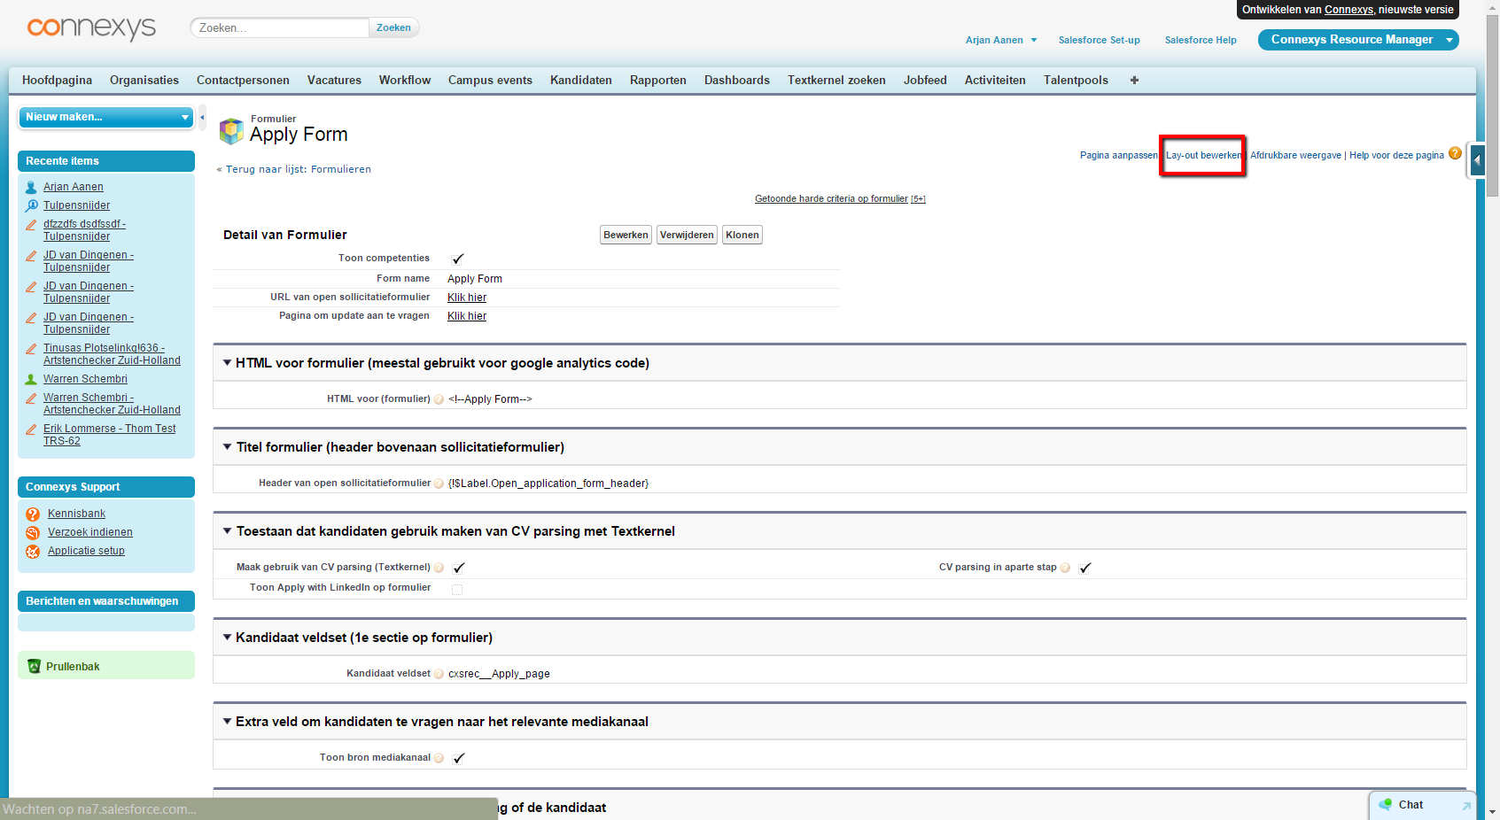

- Scroll down, find the field, and click the edit icon ‘properties’.

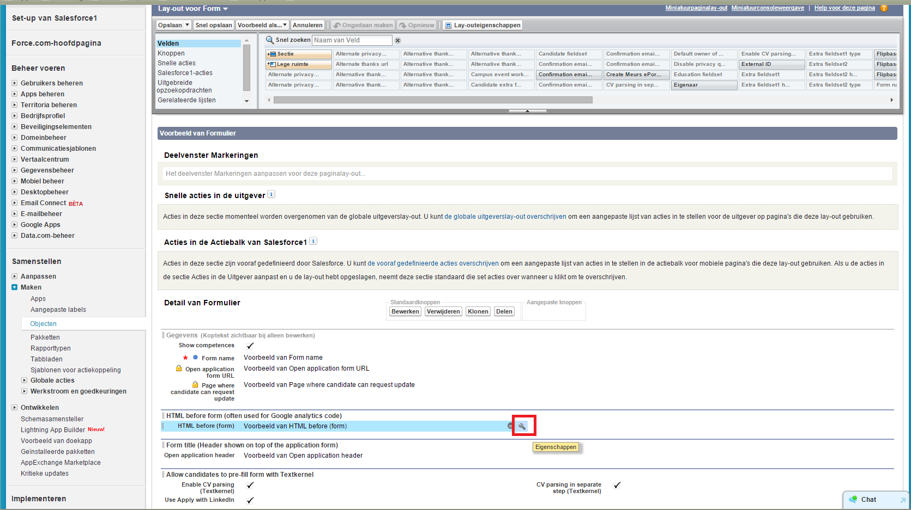

- Check: required.
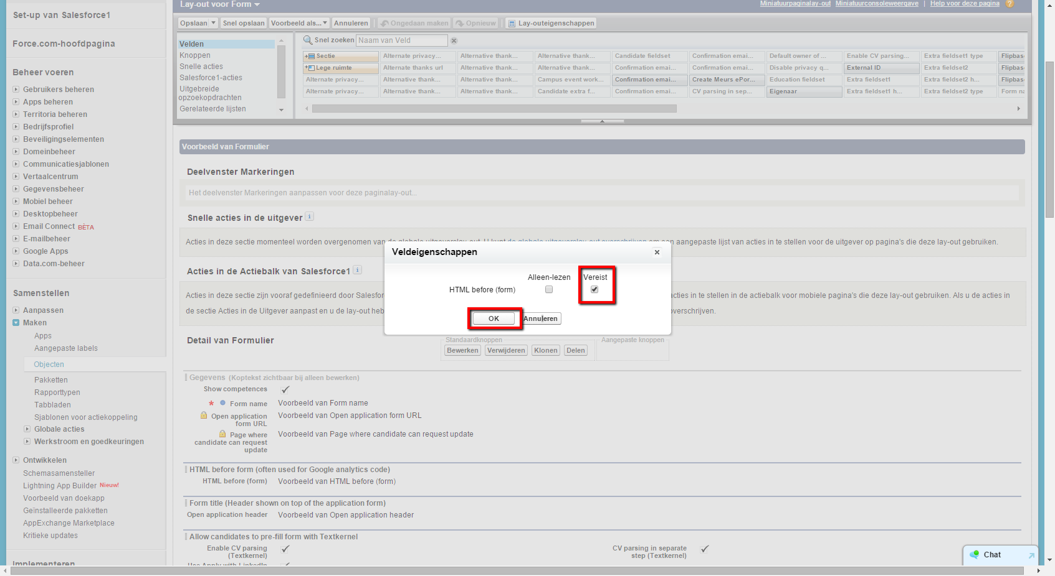

Now the field is set required, and will show red on the form.

